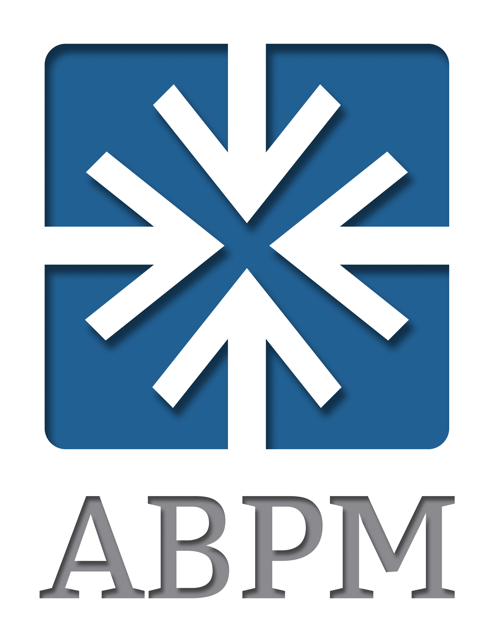

2019 (In-Person) & 2020 (Virtual) Fall Workshop Series Evaluation Statistics and Quotes

100% of 2019 (in-person) and 2020 Fall Workshop Series (virtual) participants said they were satisfied or extremely satisfied with the 2019 and 2020 Fall Workshop Series (70% of the 2019 and 58% of 2020 participants responded they were extremely satisfied with the conferences).

100% of 2019 (in-person) and 2020 Fall Workshop Series (virtual) participants said they were likely or extremely likely to recommend the conference to a colleague (73% of the 2019 and 84% of 2020 participants responded they were extremely likely to recommend the conference).

Open-ended quotes:

“First Fall Workshop series for me. I found this to be very valuable (even in a virtual setting) for learning what other programs are doing in the virtual world. The workshops with small group breakouts and time to collaborate were very effective in my opinion.” - Thomas Pofahl, Red Hat, 2020 Fall Workshop Series (Virtual)

“As a first timer, nothing was more valuable than the great people involved! The event was very well organized with exceptional content that I can put into practice afterward.”
– Alley Caffrey, Netskope, 2019 Fall Workshop Series (In-Person)

“The fall conference provides an excellent opportunity for you and your team to hone their skills and identify new best practices to build into your plan for taking your program to the next level. I’m always pleased to find I leave affirmed in my program’s strengths, a bit humbled at the opportunities, and inspired with new ideas.” - Anonymous

“I loved the ability & willingness everyone had in sharing their Best Practices that they utilize. Whether we are competitors in the market this did not get in the way of some great conversations !!” - Tena Black, Dell Technologies, 2019 Fall Workshop Series (In-Person)

“Very well organized with engaging moderators. The experience was the same great quality from workshop to workshop.” – John Panek, Zebra Technologies, 2020 Fall Workshop Series (Virtual)

“The fall workshop series provided great insight and allowed to foster enriching conversations with peers. I love the deep dives and great conversations.” - Shaun Mohammed, Rogers Communications, 2019 Fall Workshop Series (In-Person)

